Signs and Wonder: The Groundbreaking Developments of an Israel Prize Laureate

Miniaturized medical devices, green technology, advanced radars, and new methods for artificial intelligence are just some of the technologies being developed by Prof. Yonina Eldar of the Weizmann Institute of Science, an Israel Prize laureate in engineering research and one of the world's leading researchers in the field of signal processing.

Itai Nebo, Davidson Institute of Science Education | 07.03.25 | 07:43

“It is incredibly exciting and humbling to be part of such a distinguished group of people whose contributions are so significant, each in their own field,” said Prof. Yonina Eldar, in an interview for the Davidson Institute website, after it was recently announced that she would receive this year's Israel Prize in Engineering Sciences. “It is very exciting to be recognized for the work we do in the laboratory, and for the importance of the field of signal processing and its contribution to the advancement of science and technology. The recognition that scientists in Israel are leading groundbreaking research in so many fields, especially during these challenging times, is especially important to me”.

Going All the Way
Eldar, a professor in the Department of Computer Science and Applied Mathematics at the Weizmann Institute of Science, will receive the prestigious award for her research “in the development of algorithms for signal processing and information processing and artificial intelligence,” as written in the announcement of the prize committee. In practice, this means that Eldar and the lab team are developing a wide range of sensors that are sensitive to a wide range of signals - for example, visible light, radio waves, and sound waves - along with innovative methods for capturing and processing this information.

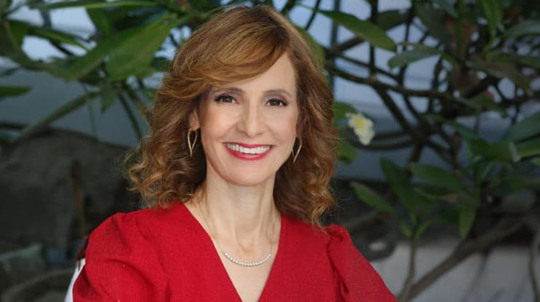

“Our main principle is to extract as much information from signals as possible in the most effective and resource-efficient way possible,” Eldar told the Davidson Institute website. “Therefore, some of our developments enable the miniaturization of technologies and their accessibility to new applications”. The developments of Eldar and her colleagues include a miniaturized ultrasound device whose diagnostic capabilities even exceed those of a standard ultrasound device, or a tiny medical radar that can be hung on the wall and used to measure the vital signs of those present in the room.

Unlike most laboratories in academic institutions, Eldar’s team doesn’t settle for developing methods but rather go all the way - from the physical or mathematical idea of ​​how to improve signal reception and the quality of the information produced from it, through the methods for processing this information for a specific application - in many cases with the help of artificial intelligence developments - to the engineering part of developing a product that uses the technology.

“This is a unique laboratory that does a lot of basic science in physics, mathematics and engineering, and emphasizes application, including working with hospitals or external companies on the development and testing of the product,” Eldar added. “That's why we have a large team of employees: engineers, computer scientists, clinicians, and more, and the research done by the students in the laboratory forms parts of this network and integrates into it. It's important to me to create an impact that will improve people's lives”.
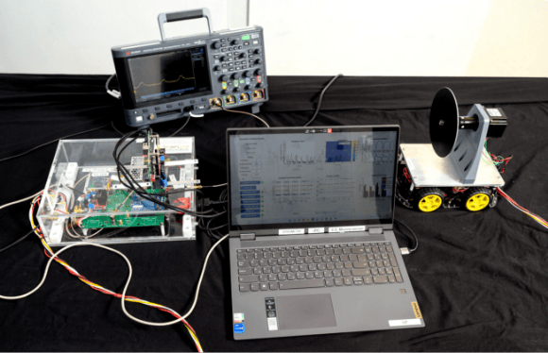
A laboratory that performs the entire process, from idea to engineering development. One of the SAMPL laboratory systems in the development phase (photo courtesy of Eldar’s lab)

Yonina Eldar (née Berglas) was born in 1973 in Toronto, Canada, the third of eight children of community rabbi Meir Berglas and his wife Vicki née Schoenfeld. Her grandfather, Rabbi Mordechai Schoenfeld, was a community rabbi in the United States and a local Zionist leader. Both of her parents were educators who dreamed of Zionism and peace. “The name Yonina expresses this longing – it means ‘little dove’ in Hebrew,” she smiles.

When she was six, her parents made their dream come true, and the family immigrated to Israel. They first lived in Petah Tikva and later settled in Ginot Shomron. In high school, she chose to study at an all-girls Jewish high school in Tel Aviv, and continued her national service in the Bnei Akiva movement, which, in addition to the routine activities of the youth movement, also included a great deal of work with the new immigrants who arrived at that time from the countries of the former Soviet Union and Ethiopia.

After completing her national service, Eldar earned a bachelor's degree in physics and electrical engineering at Tel Aviv University. “My parents always valued learning and knowledge and were also very active in the community in a variety of fields. It was important to me that my studies also combine both things – theoretical knowledge with practical work that affects society, pure science, and applied science that would include working with people and impacting people's lives,” she said. “I was accepted into the honors program that made the double-major degree possible, but back then there was no such official track, and I had to deal with quite a bit of bureaucracy and overlapping courses. After I finished both degrees, the deans sat down with me and put together a combined physics and engineering program”.
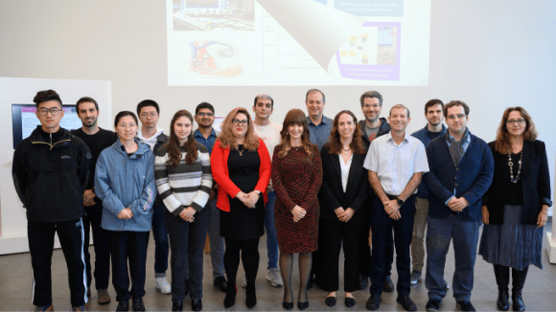

Believes in taking opportunities, as well as giving opportunities and promoting gender, sectoral, and social diversity in the laboratory. Eldar with her research group team (Photo: Weizmann Institute of Science)

Eldar continued her master's degree in electrical engineering under the supervision of Prof. Ehud Weinstein. Not long after, Weinstein's good friend, Prof. Alan Oppenheim of the Massachusetts Institute of Technology (MIT), who is considered one of the pioneers in the field of signal processing, visited Israel. “He encouraged me to enroll at MIT and continue my studies with him, and I did, even though I didn't plan it. Sometimes you have to make room for opportunities in life, and when the opportunity came, I took it”.

Trust the Processing
That's how Eldar, then a young mother of an eight-week-old baby, found herself starting her doctoral thesis at MIT in Boston, researching quantum aspects of signal processing. “In our work, we used physical principles from quantum mechanics to develop innovative methods for processing classical signals. The other direction was the opposite: to use signal processing algorithms to handle quantum information. We came up with interesting things in both subjects, and today the principles and methods we developed are used,” said Eldar. “But beyond science, I learned a lot from working with Oppenheim. He runs a unique research group, encourages thinking outside the box, and pushes students to push themselves to the limit in terms of thinking and creativity.”

Eldar rejected offers to stay in the United States and work at MIT or Stanford University in California. Instead, she preferred to return to Israel, and established the SAMPL laboratory for sampling, sensing, and processing signals at the Technion. “We established a first-of-its-kind signal processing lab that looks at end-to-end systems – from physical sensing, through the hardware that translates the data into digital information and the algorithms that decode it according to the application, to the user interface.”

In 2019, after 17 years at the Technion, Eldar moved her lab to the Weizmann Institute of Science, where she also currently heads the Center for Biomedical Engineering. “The institute is a great fit for our group, because it is very interdisciplinary, with a wide range of people interested in interdisciplinary collaborations,” Eldar said. “It gives us a push to do the best science, without restrictions or earmarking for specific fields, and it also opens up many possibilities for students”.

Changing the Rules of the Game
Eldar is a world-renowned expert in radar applications – a field where her breakthroughs in signal sensing and processing are widely used. The applications she developed are used in many security and safety systems, and in recent years also in autonomous vehicles that need to quickly absorb and process a lot of information from the environment.

Another area where these developments are being applied is radar technology for non-contact vital signs monitoring (NCVSM), a groundbreaking technology, where Eldar is among the world's leaders in its application. “One of our developments is a radar that allows very subtle movements to be measured remotely, such as the up and down movements of a person's chest while breathing,” she explained. “What makes our development unique is the algorithm, which allows for accurate monitoring of heart rate and breathing, even of many people at the same time in crowded places. This system combines accuracy, scalability, and versatility”.

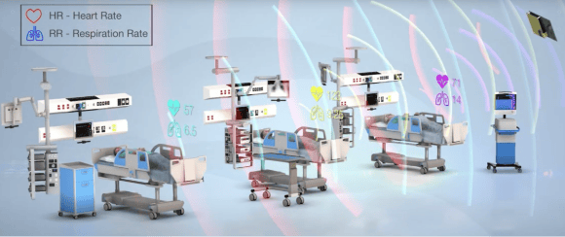

Such radar systems open up a wide range of applications. Their potential is not limited to healthcare systems, such as monitoring epidemics or tracking the health of the elderly, but also to industrial safety systems, ecological systems, and other monitoring systems.

Another major project that Eldar's lab is currently focusing on in the medical field is the miniaturized ultrasound device. Medical ultrasound technology has been around for about seventy years and is based on high-frequency sound waves. These waves travel at different rates through different types of fluids and tissues, so their reflection patterns can be used to build an image of the medium they have passed through, for non-invasive medical diagnosis.

“The idea is to take a large, cumbersome device, minimize the sensing – in this case, the sound waves – and replace it with a simple transducer that connects to a smartphone. “If in a regular ultrasound, the information from the sound waves is translated into an image that physicians decode, and our method makes it possible to use additional layers of digital information, thanks to the advanced signal sampling method,” Eldar explained. “We can not only produce a better image but also use additional physical parameters for diagnostic purposes that are not included in the image. There is a treasure trove of data here that was not available with previous methods, and with the help of advanced signal processing and the use of artificial intelligence, we can obtain additional information in the miniaturized device that is currently not available with a regular ultrasound”.

The tiny ultrasound device, which will also be designed to be wearable and will enable continuous medical monitoring, is currently in the stages of being finalized for commercial production, and the intention is to establish a company that will manufacture and market the device. Additional developments in Eldar's laboratory are also in similar adaptation processes, after patents were registered for them. Among them are the medical radar for providing real-time data on vital signs of hospitalized patients in the room, as well as additional developments in the fields of security, safety, communications, autonomous vehicles, and more.

The applied aspect of the activity runs parallel to the scientific aspects, which include over a thousand scientific articles signed by Eldar, 11 books, including a major textbook in the field of signal processing, and dozens of chapters in books. “It is important to me that our developments harness technology for the benefit of humanity and be used for applications that contribute to life and quality of life,” Elder emphasized. “What excites me, besides the applications themselves, is the working principle: We do not start from the application, but from the basic principles and physical or mathematical limitations of signal reception and processing – accuracy, power, compression, and so on. This is how we change the rules of the game and enable a variety of future applications”.

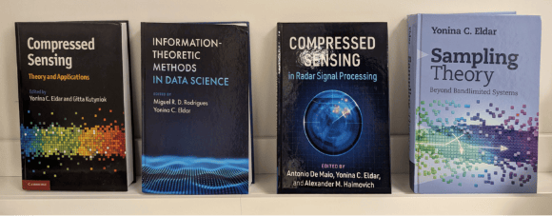

Small Samples, Big Gains
The main change in the rules of the game that Eldar led and continues to lead was defined in the announcement of the Prize Committee as “challenging the classic sampling theorem”. The sampling theorem is at the center of sampling theory, which defines the basis for the field of signal processing and determines the principles, limitations, and requirements for transforming any signal – light, sound, radio waves, brain waves, or any other wave – into a sequence of numbers that can be processed digitally. The sampling theorem, developed about a century ago and also called the Nyquist theorem or sometimes the Nyquist–Shannon theorem, defines the relationship between the frequency of the signal and the frequency at which it must be sampled in order to obtain a reliable measurement and avoid bias. For example, if the signal has a frequency of 50 Hz, i.e., 50 signals per second, but the measuring device can only receive twenty signals per second, we lose a lot of information. Therefore, we will not have a representative image of the signal and its processing will be incorrect.

An example of this can sometimes be seen in movies and television shows where the camera follows a moving car. It often seems to viewers as if the wheels of a car moving forward are turning backwards. The confusion arises because the camera's frequency, that is, the number of frames it captures per second, is less than the speed of rotation of the wheel.

High-frequency sampling requires appropriate equipment that is not always easy to obtain or produce. Even when it is available, its use has other costs that complicate the technology. High-frequency sampling consumes more energy and shortens battery life, requires more computing power to process the data, and more. So those involved in processing it strive to obtain as much information as possible in as few samples as possible. This is precisely Eldar's great breakthrough.

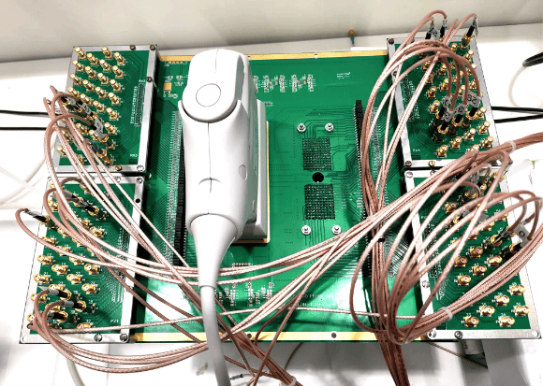

It is possible to break through physical boundaries and obtain more information with less investment. Prototype of the advanced medical ultrasound system (Photo courtesy of Eldar’s lab)

"We have demonstrated that it is possible to break through these limits and represent many signals even at a lower sampling rate, thanks to the use of additional information inherent in the signal or of things we know about its characteristics,” she explained. "The rules of the Nyquist theorem are correct, but when you take into account the needs of specific applications and the characteristics of the signal, you can bypass them and achieve the same accuracy and sometimes even better accuracy even if you sample at a lower frequency, which consumes fewer resources”.

Green Sampling
Low-power sampling techniques have become a subfield of signal processing in recent years, known as Green Data Acquisition. Such methods not only consume less energy in the signal acquisition process but also save energy in the processing and storage of science, because there is less information. Extending the life of the device and batteries thanks to low power consumption can be very significant, for example if the device is an implanted pacemaker that needs to be replaced surgically every few years. Energy saving is also important in applications such as the Internet of Things, sensors that are installed in products and report on their status, and even more important in chips and systems for artificial intelligence applications, whose power consumption is high due to the large amount of information they process.

“One way to reduce energy consumption is indeed to move to sampling at a lower frequency, but there are other ways that we are developing,” Elder emphasized. "For example, we have developed a method to convert an analog signal to a digital signal without requiring a clock, which is currently a component of almost every digital system and consumes a significant portion of its power. To do this, we need to look at the information differently, and sample it only when the signal strength exceeds a certain threshold, and not at a constant frequency. We discovered that from the parts that we sample with this method, it is possible to reconstruct all the information about the signal that we are sampling”.


Prof. Eldar at the Defense High-Tech Conference

Eldar's scientific work has earned her many important awards over the years, including the Krill Prize (2005), the Weizmann Prize for Exact Sciences (2011), the Technical Achievement Award from the American Society for Signal Processing (2013), the Taub Prize for Academic Excellence (2015), and the Landau Prize for Science and Research (2023).

The Social Laboratory
In addition to her scientific activities, Eldar has worked throughout her career to promote the integration of women in science. In recent years, she has done so in an official capacity, chairing the Gender Equity Committee of the Council for Higher Education. In this way, she works to increase the number of women in academia.

"The Committee aims to promote the integration of women in academia in an organized manner, with budgets," notes Eldar. "We launched the 'Equator' program, which promotes women at all levels, from students to senior researchers, and rewards institutions based on meeting targets. We also ensured that every academic institution would have a female gender equality advisor to the president of the institution, who would be responsible for implementing the program and would also act to provide a response for women in the institution. Such a change needs to happen everywhere, not just in academia, but I hope that people and women who leave academia for other systems will bring these principles with them”.

As one of Israel’s youngest professors, Eldar faced – and still faces – the demanding combination of career and family, as a mother of five children: Yonatan (26), Moriah (22), Tal (19), Noa (13), and Roee (10).

Balancing an academic career with raising a family is an ongoing challenge, and too often talented scientists, especially mothers, are forced to make difficult choices that limit their professional growth. That is why I am working, together with many colleagues to whom this issue is important, to create an environment that will allow female scientists the ecosystem necessary to be mothers and also continue excellent scientific careers, including in my lab”.

In her lab, Eldar is careful to maintain gender diversity, with impressive representation of female students, but in a mixed company. "Gender, sectoral, geographic, and political diversity in the lab is very important to me. It's good for the lab and for creativity, and good for the promotion of teamwork, getting to know each other, and contributing together. I hope that this experience, beyond the scientific side of the work, will be integrated into their identity as citizens in the future, so that they will see that it is possible to work together even if we disagree on other things," she says. "Of course, I do not compromise on the professional level of the students, but we must remember that not everyone can express their abilities in the same way, and sometimes we need to be given the opportunity to do so in a different way. Many times, female students can lack self-confidence in presenting their work in public, but that does not mean that they have less knowledge or ability”.

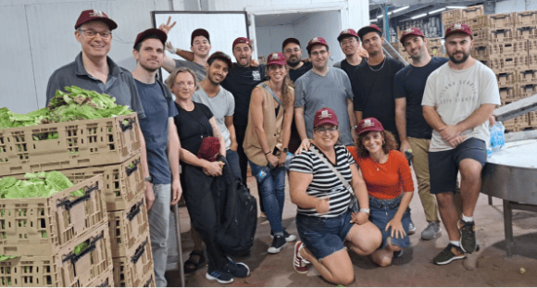

Making sure to volunteer a lot, not just in scientific matters, to foster social responsibility. Eldar's research group volunteering for agricultural work (photo courtesy of Eldar’s lab)

Eldar's lab also makes a point of hosting groups of high school students from all sectors. "A lot of groups of female students come, and it's important for us to encourage them to choose science subjects and show them that they are capable, along with students from the geographical and social periphery and gifted groups. We try to reach everyone, present the importance of studying science and technology and show that it's possible," Eldar emphasizes. "People from the lab also volunteer to conduct activities in schools in the periphery. As a lab, we also volunteer for activities that are not related to science, such as agriculture in the southern region or working with people with disabilities. It's important to me that there be social responsibility for those who come to my lab, and it's important for us to create a social impact”.

Eldar has mentored hundreds of research students over the years, and she sees working with students as a central part of her mission. "I have been blessed with the privilege of teaching – maybe even educating a little – many students, and that is very important to me. I don't know if my scientific work will impact humanity, and if so to what extent, but I hope to be a part in the way of young and talented people to exploration, influence, and change. This is a more significant contribution than the discoveries themselves”.

Itay Nebo, Davidson Institute for Science Education, the Educational Arm of the Weizmann Institute of Science

